**Business analyses tasks – Reports**

Task 01. Create Packages for Reload Dimension from SA_*

Users DW, DW_CL with necessary privileges were created by running commands which were added in attached file init_users.sql.

Tables on DW Layer were created by running scripts from directory \dw\tables\.

Necessary sequences were created on DW_CL Layer by running scripts from directory \dw_cl\sequences\.

To reload DIM data were created next Packages (presented in directory \dw_cl\packages\):

1**. Pkg_etl_fin_groups_dw** - to load data about finance groups from source table using explicit cursor. Result of procedure execution is presented below.

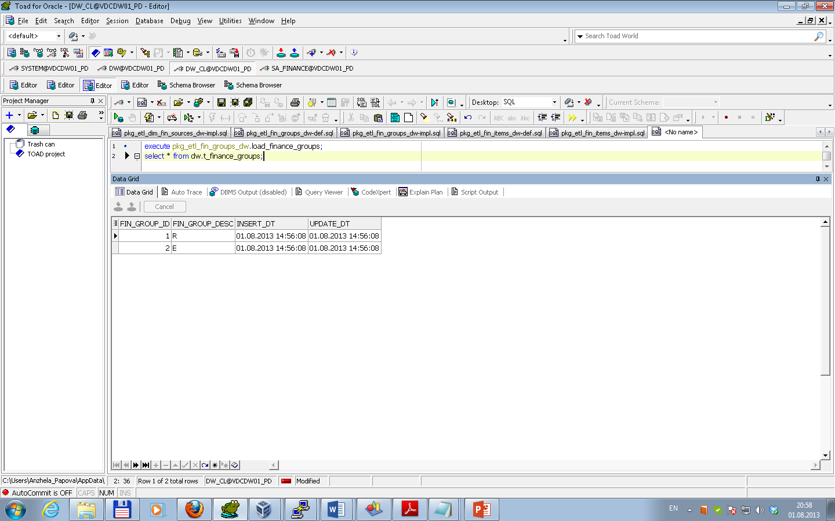

After multi execution result is the same.

To test data for consistency was used result of expression (direct and inverse) as select from procedure execution minus select data from source table. Test results are presented below.

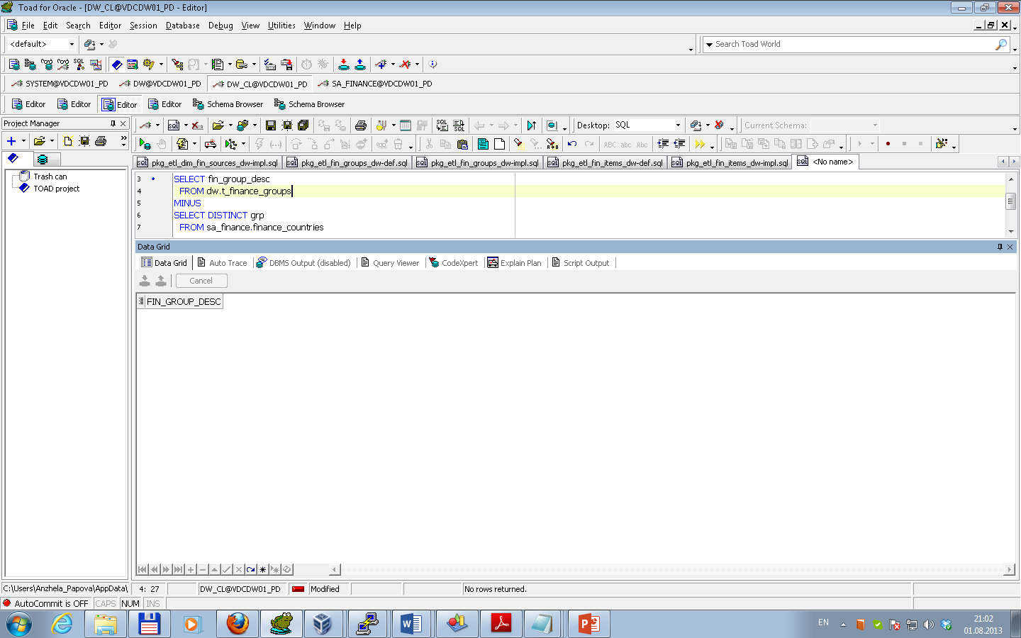

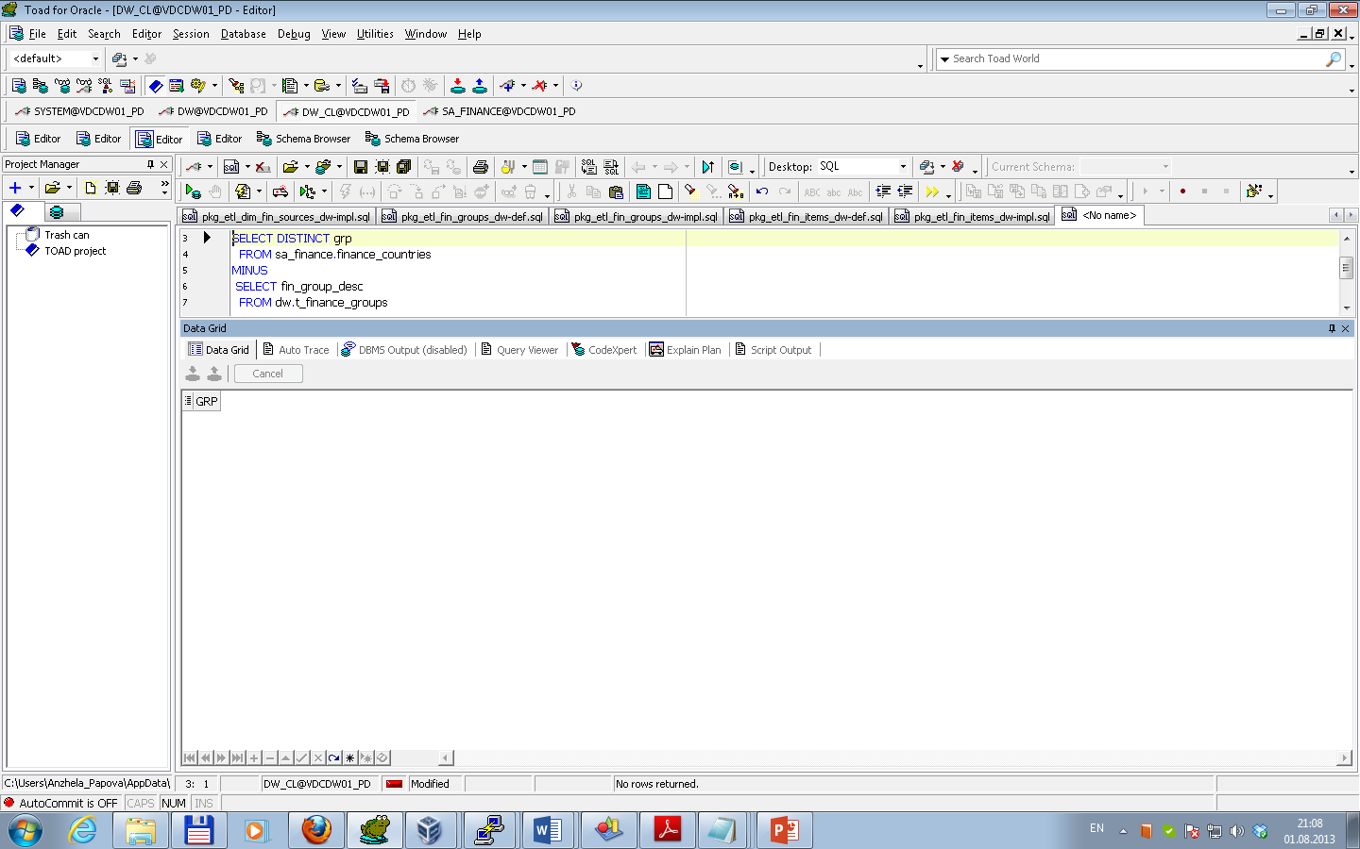

2**. Pkg_etl_fin_items_dw** - to load data about finance items from source table using explicit cursor and FORALL Bulk Insertion. Result of procedure execution is presented below.

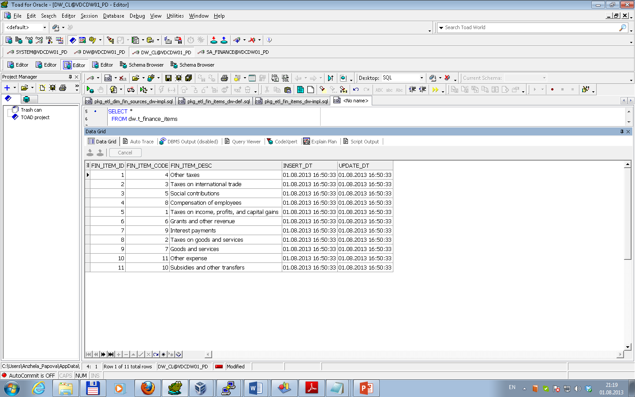

After multi execution result is the same.

To test data for consistency was used result of expression (direct and inverse) as select from procedure execution minus select data from source table. Test results are presented below.

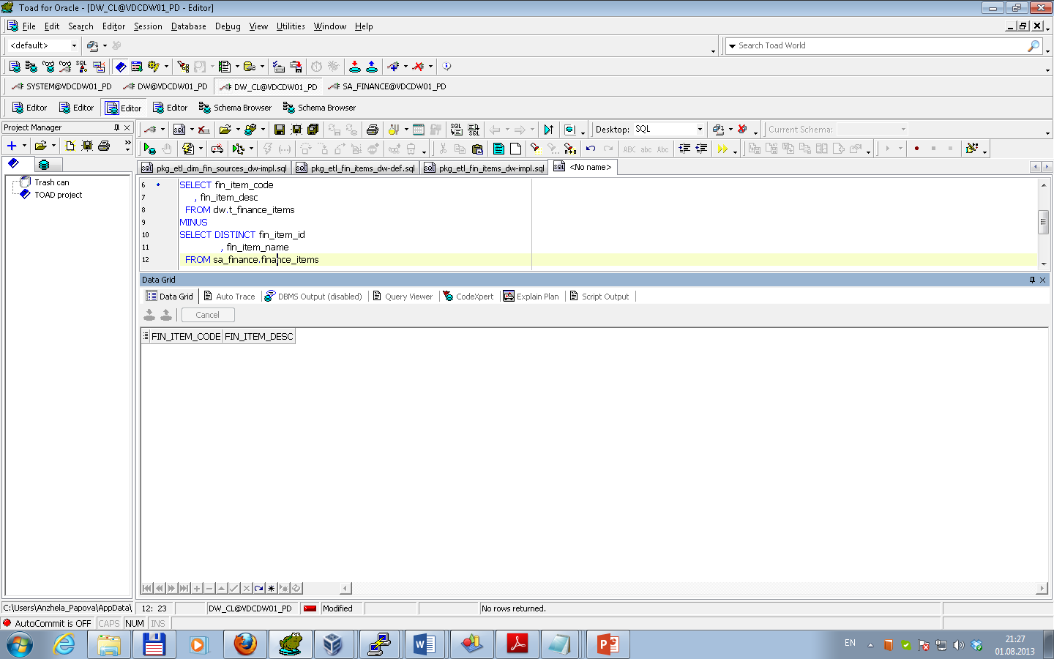

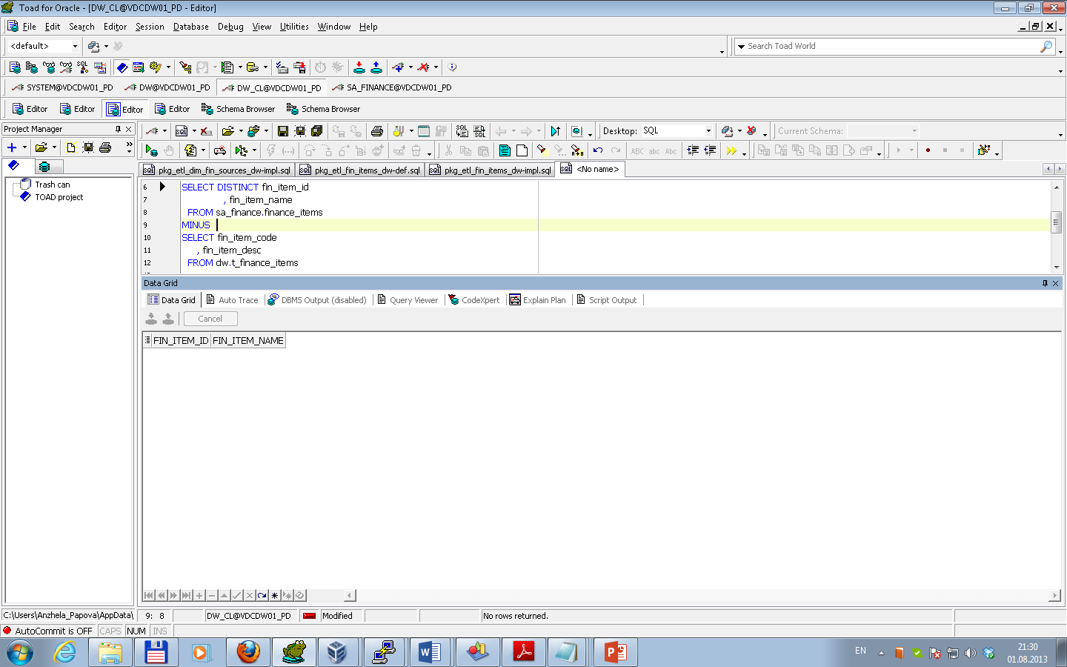

3**. Pkg_etl_gen_periods_dw** - to load data about levels of budget deficit from source table using variable cursor and FORALL Bulk Insertion. Result of procedure execution is presented below.

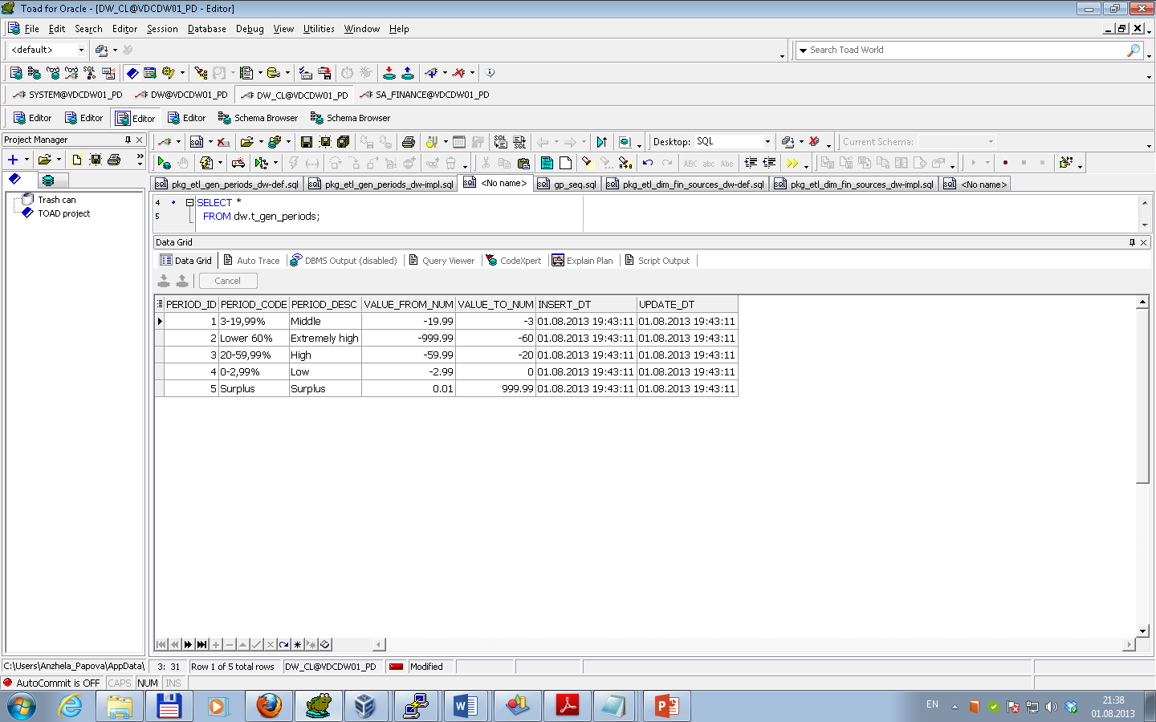

After multi execution result is the same.

To test data for consistency was used result of expression (direct and inverse) as select from procedure execution minus select data from source table. Test results are presented below.

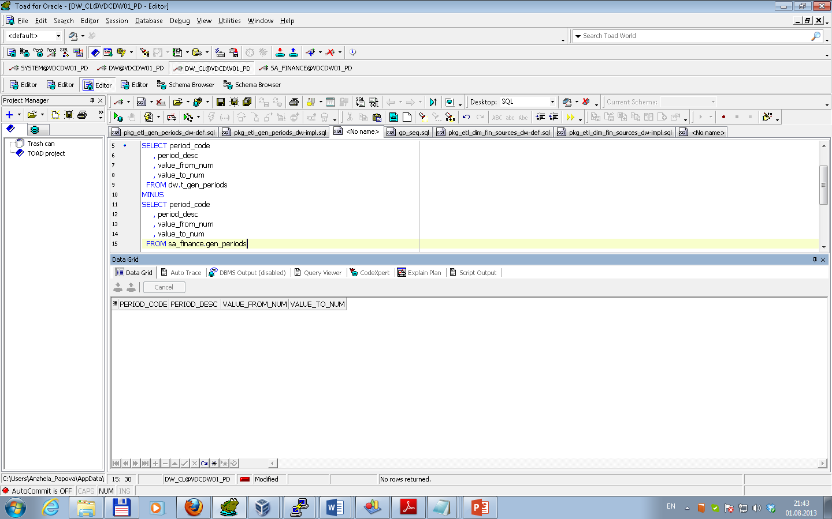

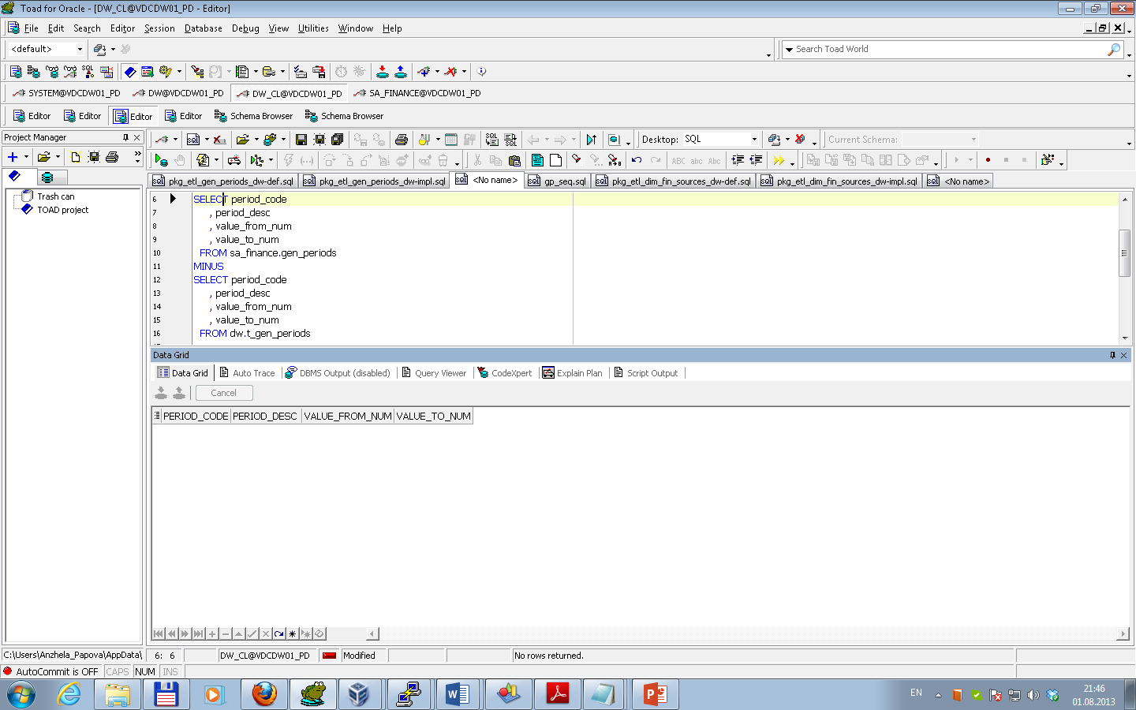

4**. Pkg_etl_dim_fin_sources_dw** - to load data about finance sources from source table using merge. Result of procedure execution is presented below.

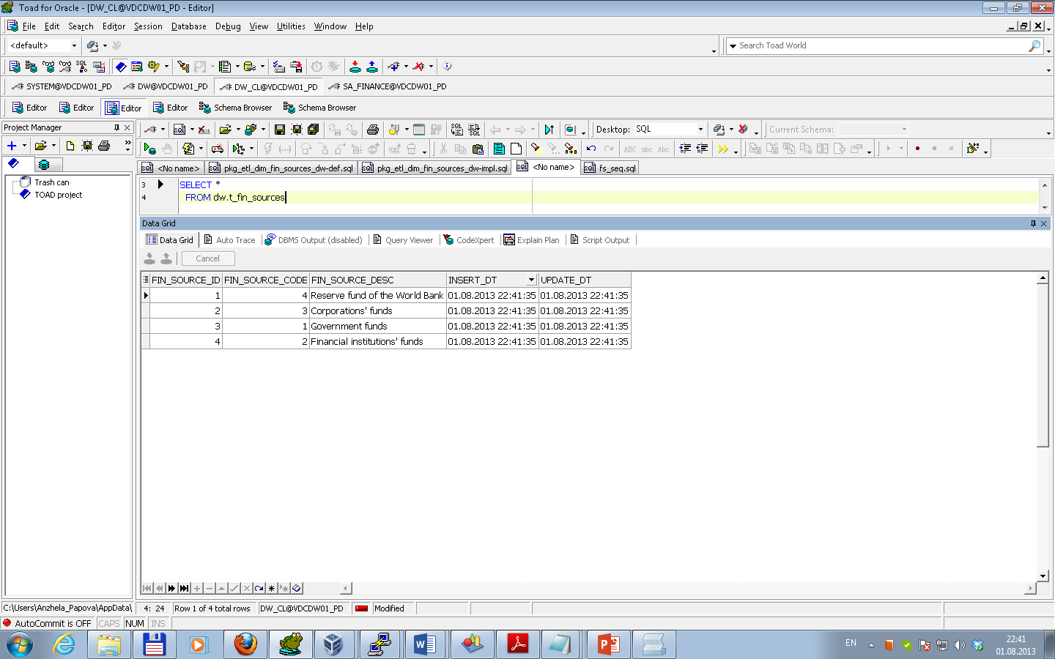

After multi execution result is the same.

To test data for consistency was used result of expression (direct and inverse) as select from procedure execution minus select data from source table. Test results are presented below.

